## Introduction

The purpose of this document is to establish that the anti-competitive effects of the voucher scheme for VHCN envisioned by the Cypriot authorities is limited. To do this we will discuss potential issues where the scheme may create undue advantage and describe countermeasures the authorities could put in place to prevent them from being realized.

The voucher scheme is intended as a measure to increase the demand side for VHCN by directly subsidizing the consumer. The amount intended is a 120 euros voucher over a period of 1 year. For example, if the monthly rate to the consumer is 20 euros, the consumer would end up paying 20-(120/12)=10 euros a month. Each household can only receive a single such. The total number of beneficiaries is 82,000 households, for a total of 10M Euro subsidy over the period 2022-2025. As such this is a very ambitious project that aims to reach 82/350= 23% of households.

The voucher will be a fixed and pre-specified amount (i.e., a lump-sum subsidy) and NOT a percentage of the price of the plan. Otherwise, the scheme would render the demand relatively more inelastic than before the introduction of the scheme, which could give the operators an incentive to increase prices, which would be counter-productive given that Cypriot prices are already significantly above the EU average. If the voucher is of a fixed amount, operators will still have the incentive to compete on the economic terms of their respective offers.

The practicalities of the voucher will be that the consumer subscribes, then the operator establishes the connection, the speed is then tested and if it meets required speeds[1], then the operator can claim the voucher amounts.

The amount of the voucher will be set as a function of the connection cost of households as well as the current average price of plans across operators. It has been evaluated that the voucher will not result in subsidizing more than 50% of any of the plans currently on the market in accordance with EU guidelines. (link to EU regulation here) Additionally since the voucher must be distributed within a single year, it is in accordance with EU regulation stating that vouchers should be distributed within two years. (link to EU regulation here, EU BROADBAND GUIDELINES).

## The intended function for the use of vouchers: boost demand

The intended goal by the Cypriot authorities for this voucher scheme is to increase subscription rates to fast broadband in Cyprus. According to the Digital Economy and Society Index 2022[2], Cyprus already has a 100% coverage of Fast broadband which is above EU average of 90% and 41% for very fast broadband which is below EU average of 70%. However, where Cyprus lags behind is on the take-up of these services, where 26% of households have subscriptions to at least 100Mbps fixed broadband compared to 40% of European average and 0.17% have subscriptions to at least 1Gbps compared to 7.52% EU average.

The appropriateness of demand side vs supply side policies depends on the conditions of the market. A supply side measure such as subsidizing infrastructure or co-financing fixed costs of operators would have been a better idea if the obstacle were high fixed costs to provide the services. On the other hand, if the supply was in a relatively good condition but it was simply consumer inertia which slowed down take-up of faster internet connections then a demand side measure would be most appropriate. Cyprus finds itself in the second scenario, where services are available but consumers are not opting for higher speeds.

As such, since Cyprus already has a relatively high coverage, the Cypriot authorities have deemed a demand side measure to be most appropriate for increasing the average Cypriot internet speed when it comes to stimulating up-take.

## Addressing potential market issues associated with the use of subsidies

## Current market conditions and the size of the intervention

The Cypriot market is described by a large incumbent who was formerly a state-owned enterprise, Cyta and three smaller firms which have gradually gained a foothold in the market, MTN, EPIC, Cablenet.

The three main markets which are relevant for this intervention are Mobile, Fixed, and TV services. Their respective sizes in market value in Cyprus are 218M, 124M and 30M euros. The subsidy will be a total amount of 10M over 3 years. Which means that the subsidy will be 8% of the market value of Fixed broadband or 2.7% of the market value over the three-year period.

|  |  |  |  |  |  |
| --- | --- | --- | --- | --- | --- |
|  | Retail market shares[3] | | | | |
|  | Cablenet | Cyta | Epic | Primetel/MTN | Total market value |
| ***Mobile*** | 1% | 51% | 39% | 9% | 218M |
| ***Fixed*** | 27% | 48% | 9% | 16% | 124M |
| ***Tv Services*** | 13% | 69% | 0% | 18% | 30M |

As can be seen above, four providers have heterogenous capabilities in the various markets. Specifically, Cablenet specializes in Fixed broadband (27%) and has low presence in Mobile (1%) and TV services (13%). In comparison, Epic has a strong presence in the Mobile Market (39%) but limited presence in Fixed (9%) and TV services (0%).

## Bundling

A natural cause for concern that results due to the above market shares is that a player who is strongly situated in numerous markets can use their position to further gain market share in the other markets through bundling. Bundling is defined as the practice of offering to consumers a lower price for a certain good when it is bought with other goods versus when it is bought individually. Specifically in this case, if Cyta or MTN were to bundle for example TV services with Fixed broadband, they would be able to attract Epic subscribers to them. And similarly, for Cablenet and Mobile subscription services.

However, the cause for concern due to bundling is limited due to the current structure of the market. Bundled services remain popular with a slight increase of fixed broadband subscriptions as part of a bundle to 78%, in comparison with 73% last year.[4] Of these bundles, 61% consists of fixed telephony and broadband access. It is only the 25% of bundled connections that include IP/cable TV access. As such, it seems bundling in the Cypriot environment does not confer large market power as only 20% of the market is bundled with TV services.

The affinity to bundle will be bounded because the Cypriot authority will limit the availability of the voucher to services that all four competitors can offer. As discussed above, this means that the only bundling that will be eligible for the voucher scheme will be fixed broadband and fixed telephony.

## Pricing

In general, Cyprus has the highest Broadband prices in Europe.

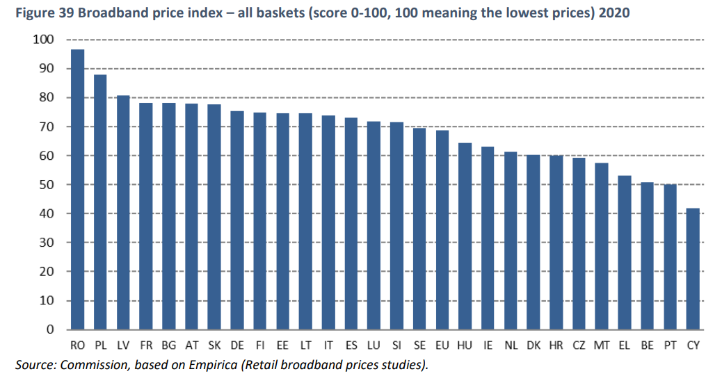[5]

Another possible cause for concern that might erupt due to a voucher scheme is that the providers will use this as an opportunity to increase their prices as consumers may make purchasing decisions based on cutoffs of monthly expenditures. For example, consumers may only consider purchases which do not exceed a certain proportion of their income, which would result in very inelastic choices for cheap products and relatively more elastic for expensive products. This would give a strong incentive to providers to increase the lower priced services.

To ensure that this does not occur, the Cypriot authority will ensure that the pricing of services which are not affected by vouchers will stay constant (whether or not the services is eligible for vouchers).

### Lock-in

The voucher as is will be locked into the initial service provider. The consumer will be permitted to switch operators during the period of the voucher (1 year) but the voucher will not be transferred to the new provider.

The effects of this kind of lock-in are expected to be limited due to the fact that the initial service provider will incur a significant fixed cost to connect the household to the network. The Cypriot authorities have purposefully designed the voucher in this way as it is of sufficiently low value to enable the initial operator to recuperate the fixed cost without subsidizing operating costs and hence will not affect the prices, this is in accordance with the EU broadband guideline which allow for two-year lock in.

## Wholesale market

Ordinarily the presence of a two-tiered market in the sense of retail and wholesale, would represent a market power risk. This is because a subsidy which is meant to target one part of the supply chain may in fact reach another part, generally, the subsidy will reach the portion of the supply chain that has the least competition. As such, It is important to establish why this will not occur on a particular intervention.

The wholesale market in Cyprus telecoms is a duopoly between Cyta and MTN for Fixed broadband and a duopoly between Cyta and Epic for Mobile. As seen below, however, these figures are subject to change as Cyta, Cablenet and Epic are currently investing in new infrastructure with the aim of increasing connectivity to 90% of premises by 2026. Epic has specifically secured 19M from the European Investment bank which will double the number of homes which it can connect to fiber (from 25k to 50k homes).

The size of Mobile and Fixed are, respectively 26M and 20M Euros. [6]

|  |  |  |  |  |
| --- | --- | --- | --- | --- |
|  | Wholesale market share[7] | | | |
|  | Cablenet | Cyta | Epic | Primetel/MTN |
| ***Mobile*** | 0% | 68.6% | 29.6% | 1.8% |
| ***Fixed*** | 0% | 40% | 2% | 58% |

However due to the nature of the subsidy, which will be directly to consumers, the relative negotiating positions of these actors will be unaffected. That is, since this is a demand side subsidy, the relatively low competition in the wholesale market will not affect the retail market. As such this subsidy is of low risk for the re-distribution of profits among firms.

Additionally, the Cypriot authorities have historically obligated Cyta and other wholesalers to provide equitable conditions for the use of their infrastructure, where most recently such a measure has been enforced on Cyta which has resulted in Cyta paying a fine.

## Technological effects

Under symmetric circumstances a flat subsidy should benefit all players equally. If however there are conditions attached to the subsidy then a differential ability to meet those conditions may imply that the subsidy will not have neutral effects. An especially important feauture which will violate the non-neutrality of the subsidy are the heterogenous technological abilities.

The current structure of the market is such that the basic services are DSL and the upgraded services being Cable with very few households having the ultra fast services(FTTH). The main operator that provides cable is Cablenet with MTN and Epic slowly developing similar capabilities. In general, Cyta is used relatively more frequently among users who opt for slower connections.

As such, since consumers choose other providers when opting for faster speeds, it is expected that this trend will continue should the demand rise. Since the voucher is expected and intended to increase the internet speed of consumers, it would also be reasonable to expect that consumers will shift to the other providers who are more popular with the higher connectivity. This implies that the effect of the subsidy on the market will be pro-competitive.

Conclusion

1. 1 Gbps download speed, and 200 Mbps upload
2. https://digital-strategy.ec.europa.eu/en/policies/desi
3. This data is collected by the national regulatory authority of Cyprus(Henceforth, NRA)
4. Digital Economy and Society 2022, Cyprus(DESI), pg.4
5. Digital Economy and Society Index (DESI) 2021 Thematic chapters
6. NRA data
7. NRA data